Legacy Local Rules
As defined on the back of the scorecard
Water hazards are defined by yellow stakes or lines.
Lateral hazards are defined by red stakes or lines.
Out of bounds is defined by white stakes, roadways, and boundary fences.
Lost ball. A player whose ball is lost or hit into the native grass areas may, with penalty of one stroke, drop a ball within two club lengths, no closer to the hole, of the point of entry. Tip: Be cognizant of the point of entry if your ball goes into a native grass area, or is potentially lost, because that could be where you will have to drop a ball. See diagrams on the next page for all the options.

Notes
- Yardage markers are to the center of the greens.
- Keep carts on paths around tees, greens, and bunkers, and out of native grass areas. Use 90 degree rule when possible.
- Please repair all marks on greens, rake bunkers, and fill divots with sand mixture.
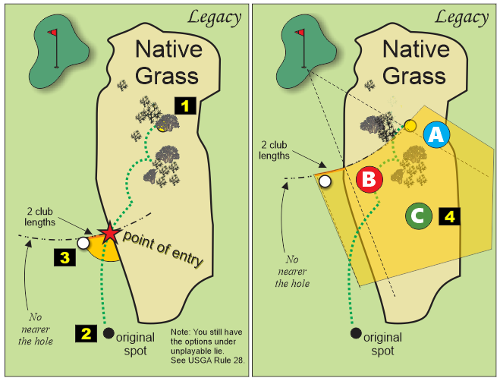
Options
- If the ball is found, play the ball where it lies. No penalty.
- Stroke and distance relief.
Play a ball from the original spot. Two stroke penalty.
- Legacy local rule.
Drop a ball within two club lengths, no closer to the hole, of the point of entry. One stroke penalty.
- Alternate to stroke and distance relief.
- Determine the spot where your ball is likely lost (point A).
- Find the nearest fairway edge no closer to the hole (point B).
- Drop a ball in the shaded area (C on the diagram on the right) as defined on one side by a line from the hole through point A and on the other side by a line from the hole through point B and not nearer the hole. The relief area is extended on both sides by two club lengths. Two stroke penalty.

