Ken McDonald
Local Rules and Clarifications
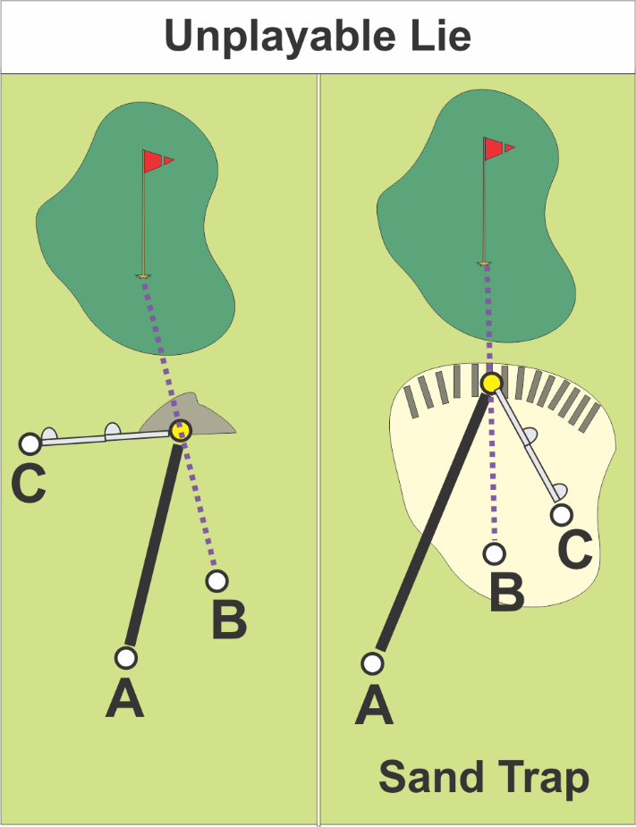
Unplayable lie, USGA video: http://www.usga.org/videos/2015/12/23/rules-of-golf-explained--ball-unplayable-4673728470001.html

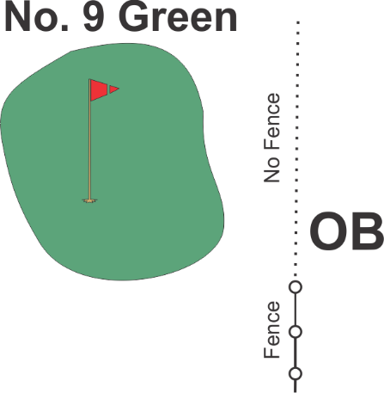

All railroad ties are an integral part of the golf course. No relief without declaring an unplayable lie. For relief, you have three options.
- Proceed under the stroke and distance provision of Rule 27-1 by playing a ball as nearly as possible at the spot from which the original ball was last played (see Rule 20-5); or
If you are in a sand trap, for options b and c, you must drop in the sand trap.
- Drop a ball behind the point where the ball lay, keeping that point directly between the hole and the spot on which the ball is dropped, with no limit to how far behind that point the ball may be dropped; or
- Drop a ball within two club-lengths of the spot where the ball lay, but not nearer the hole.
When proceeding under this Rule, the player may lift and clean his ball or substitute a ball.
Out of bounds: Generally, these are the perimeter walls and “curbs” by the exterior bike paths and not the protective fence of the bike paths.
- The landscaping to the right of No. 1 green bordered by a curb is out of bounds. The landscaping behind the No. 7 green is not out of bounds.
- On hole No. 1, inside the fenced water pump area near the right-side of the green is out of bounds. Remember that the wall is part of out of bounds and there is no relief without a penalty for an unplayable lie.
- On hole No. 7, the curb on the right side of the hole is out of bounds when playing No. 7. When playing No. 4, if you hit over the fence into No. 7, you are not out of bounds.
- On the right side of the green on hole No. 9 is an out of bounds fence by the driving range. The pro shop says that the out-of-bounds line extends to about the cart path.
- On hole No. 18, the cart path beyond green is out of bounds, the area to the right of the green is not out of bounds, nor is the practice area to the left of the green (verified by the pro shop).
French drains. You may take nearest relief from these.
Water hazards. The water’s edge defines the hazard except where marked by stakes. Red is a lateral hazard. The pro shop says most of the water on the nine holes that have water are played as lateral hazards. Hole 15 may be the exception.
Staked trees. If a staked tree interferes with a player’s stance or swing, relief may be taken. Ball shall be dropped within one club length of nearest point of relief, no nearer the hole.
Play ready golf — be ready to play when it is your turn.
New Players Etiquette Tips
On the putting green, don’t walk on someone’s line.
Flagstick Etiquette (Golf Digest and other sources)
Removing the flagstick. When you remove the flagstick, place it gently on the ground. Don’t just let it drop. It could damage the green and affect the play of others. Position the flagstick so putts are not in danger of hitting it, which would be a two-stroke penalty on the person putting. Note: Anyone can move the flagstick out of the way so that person putting can avoid a penalty. This permission was added in 2008.
Replacing the flagstick. If you’re the first person in your group to putt out, you should be the one to replace the flag.
Tending the stick. The person tending generally should not be the person who will be putting next (pace of play). Hold the flagstick so the end is not jammed into the hole, and once the ball is rolling, pull the flag straight up, and make sure you get it—and yourself—sufficiently away from the action. If the ball strikes you or the flagstick, it is a two-stroke penalty on the person putting.

