VISITING PRESCOTT AND NEARBY ATTRACTIONS
PRESCOTT
Visit Prescott
Trip Adviser - 15 things to be in Prescott
PRESCOTT VALLEY Prescott Valley
Prescott Lodging: Prescott - where to stay Camping and RV

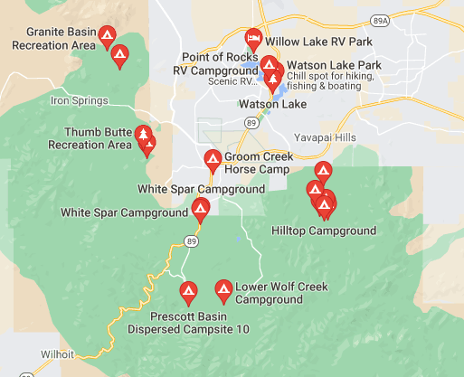

Prescott Valley - Things to do in Prescott Valley
Historic Jerome – The lovely drive from Prescott to Jerome is approximately 24 miles and takes about 50-55 minutes. Park and walk around the town, visit shops, museums, etc. The view from the top of the mountain is awesome.
Jerome AZ
Verde Valley/Camp Verde – The drive from Prescott is about 42 miles and should take approximately 55 minutes.
Verde Valley Wine Trail
Verde Valley Wine Trail Map

Dewey Mortimer Farms, Dewey Blackberry festival July 16 & 17
Breweries
Prescott Brewing Co, downtown Prescott Prescott Brewing
Lonesome Valley Brewing, Prescott Valley Lonesome Valley
Farmers Market Prescott Valley Farmers Mkt
Movie Theater - Harkins Theater in Prescott Valley
Casino – Located in the Prescott Resort & Conference Center Buckys Casino

