CLUB WEST G.C.

TWO-PERSON TEAM SCRAMBLE

Saturday, October 5, 2013

(7:30 Shotgun)
Sign-up Deadline:
Friday, September 27, 2013 5:00 p.m.
(No late entries will be accepted)

Fees: |  | $70.00 per player (includes individual team fee, $30.00), green fees, prize fund, skill prizes, cart, range balls, and tax)
Teams  Tees  Payouts |  | Each team will pay $60 into the scramble prize fund. The prize fund will be split as evenly as possible between flights. Each golfer must have an established handicap in the SRPGA handicapping system, and must have posted three (3) SRPGA individual tournament scores in current calendar year.  Low handicap golfers will play from the blue tees (6556 yds), all other men from the white tees (6128 yds) and all women from the gold tees(4985 yds).  1st and 2nd Place (each flight): scramble money only  3rd and 4th Place (each flight): pro shop gift certificates or Credit Union checks
Carts |  | Included
Skins |  | $10 per team (optional). Sign up at the pro shop before the round and pay after you play.
Format: | Louisiana Scramble (see attached sheet). 7:30 a.m. shotgun start. Please arrive 30 minutes prior to start. This is a CLOSED tournament, so only SRPGA members eligible to be flighted may play.
Directors: | BILL SANTUCCI - 602-236-8627  TOM COPELAND - 480-839-0382 |  |  | Additional copies of this flyer are available on our web site at http://www.srpgolf.com.
Pro and Location  Driving  Range | CHILO MENDOZA  Phone: 480-460-4400  16400 S. 14 AVE.  PHOENIX, AZ 85045  Grass; no restrictions |  |  | HOW TO GET THERE:  - Take I-10 East Towards Tucson  - Exit 161 toward AZ-202-loop E PECOS RD take PECOS RD. exit  - Proceed for 6.7 miles then turn right (west) on S 17th AVE., turn right onto W. CHANDLER BLVD.  Turn right onto S. 14 AVE. .03 miles
Send Check or Notice to:  BILL SANTUCCI  MS XCT329  P.O. Box 52025  Phoenix, AZ 85072-2025 |  |  | Write your partner’s name  on the check  Absolutely no cash  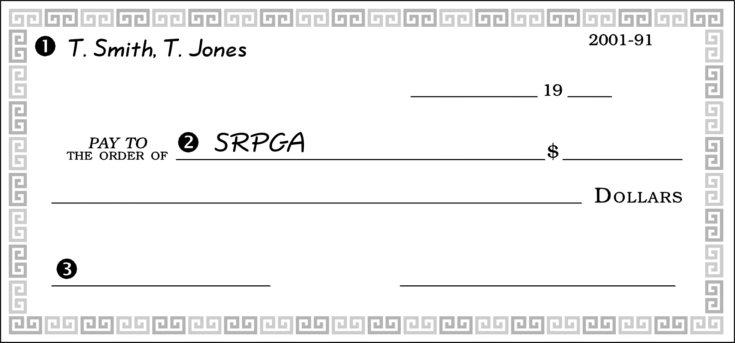  Make check out to  SRPGA.  On memo line, write  CLUB WEST
ONLINE OR PHONE PAYMENT OPTION:
If paying online or by phone, remember to notify Bill Santucci. The directors cannot assume you entered or paid.
How to pay through Altier Credit Union:
- Call 602-797-3000 and ask for “Serviceline”
- I’d like to transfer from my account to the SRPGA account #31906 $70.00 for Club West tournament fee
- Please reconfirm with the Serviceline operator your name and account number before hanging up

Two-Man Louisiana Scramble
Golf Tournament Rules

The tournament will be played as a two-person team scramble. Each team records only one score per hole on their card.
Tee shot: The two partners each hit a tee shot.

Next shots: The partner with the poorer drive moves his ball to the spot (within one club length) where his partner’s ball stopped. [NOTE: It is not mandatory for one partner to move his ball to the other’s location.] They both hit their second shots from this more desirable location. After they have hit their second shots, they again select the best location of the two and both hit from there and hit third shots. This procedure continues until one team member is in the cup.

Picking up: The other partner may pick up unless (s)he can still improve the team score.

Putting tips: Before putting, a marker should be placed next to your ball in case you miss the putt, in which case your partner would try from the same spot. You may also “tap in” a putt to speed up play instead of marking—your partner can still improve the team score; no penalty.

Improve Lies: Lies may be improved one club length anywhere on the course except in hazards, or on greens.

Hitting order: Either partner may hit first on any given shot or putt.

An example of play: Both partners hit a tee shot on a 200-yard par 3 hole. Sam hits his tee shot onto the green 20 feet from the pin. Partner Dave hit into the greenside trap. Dave picks his ball out of the trap while Sam eye’s the putt. Sam misses the putt and taps it in. Dave then eye’s the same 20 foot putt and makes it, improving the team score to 2, which is the score marked on the card for that hole.

Out of bounds: Shots out of bounds or in water hazards cost you nothing unless your partner is also in trouble on the same shot. You cannot improve your lie out of bounds by one club length so that you are in bounds.

Handicaps: These will be calculated based on each player’s course handicap according to USGA recommendation. The team handicap will be the sum of 35% of the A-player handicap and 15% of the B-player handicap.

Payout: Each flight pool is distributed to the first and second place teams on a 70-30 percent basis.
Ties:
- If two teams tie for first place, scorecards will be matched to determine the winner and second place.
- If more than two teams tie for first, the pool for that flight (100 percent) will be divided equally among the tied teams.
- If no teams tie for first, but there are ties for second place, the
second place prize (30 percent of the flight pool) is divided equally among the tied teams.

