Oakwood Golf Club

Saturday, December 8, 2012

Sign-up Deadline:
Friday, November 30, 2012 5:00 p.m.
(No late entries will be accepted)

 | Fees: | Play | $59 Includes green fees, tax, flight and skill prizes  Notes: No entries accepted without an entry check or payment online by the deadline. ALL PLAYERS MUST NOTIFY paul.thompson@srpnet.com the players in your group.
 |  | Carts | Included
 |  | Skins | $5 sign up at the pro shop when you check in and please pay one of the tournament directors after your round
 | Format: | SHOTGUN START at 8:30AM. Arrive by at least 8:00am to check-in, practice, etc. Prizes are net score by flight and skill. Non-SRPGA member golfers are only eligible for skill prizes. Tees: 1st Flt Green Tees, Men: White tees, Women: Red tees.
 | Directors: | Paul Thompson - 602-236-8930  Harry Sauthoff - 602-236-3060 |  |  | Additional copies of this flyer are available on our web site at http://www.srpgolf.com.
 | Pro and Location: | KEVIN MARUGAME (Tour. Director)  480-895-1159  24218 S Oakwood Blvd  Sun Lakes, AZ 85248 |  |  | How to Get There  From PAB, take I-10 south to Riggs Rd.  Go east to Robson Blvd.  Go north about one mile to the clubhouse and pro shop. Maps On Us says their address is about 20.2 miles from PAB, and estimates about 30 minutes to get there from PAB. (http://www1.MapsOnUs.com).  Dress Code: No denim jeans or shorts. Collared shirt, soft spikes only.
 | Driving  Range: | Grass; no restrictions
Send Check and/or Form to:  PAUL THOMPSON  PBF200  P.O. Box 52025  Phoenix, AZ 85072-2025 |  |  |  | Absolutely no cash  Make check out to SRPGA.  On memo line, write Oakwood  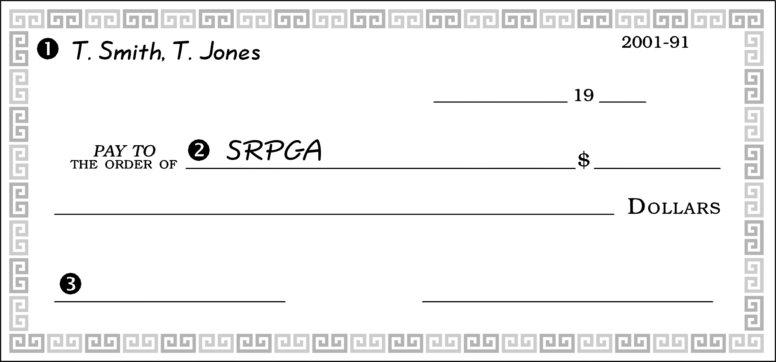

ONLINE OR PHONE PAYMENT OPTION:
If paying online or by phone, remember to notify Paul Thompson. The directors cannot assume you entered or paid.
How to pay through Altier Credit Union:
- Call 602-797-3000 and ask for “Serviceline”
- I’d like to transfer from my account to the SRPGA account #31906 $59 for Oakwood tournament fee
- Please reconfirm with the Serviceline operator your name and account number before hanging up

