Troon North
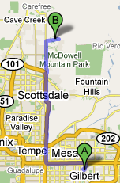
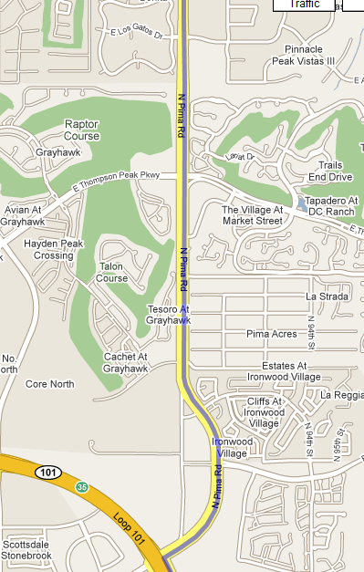
480-585-7700 38 mi, 49 min

Take the 101 N and exit at Pima Road.
Cross streets you will pass:
Thompson Peak Pkwy
Pinnacle Peak Rd
Happy Valley Rd
Jomax Rd

Turn RIGHT on Dynamite Rd.
The clubhouse is about
2 miles down and to the LEFT
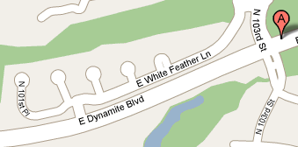
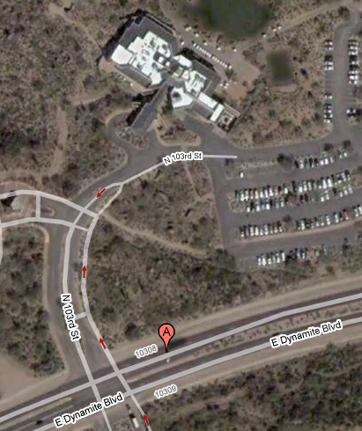

First Flight
Other Men
Women



